Quality Measures in End-of-Life Care
DPH Office of Health Planning and
Ad Hoc End-of-Life Care Workgroup
Presentation to SQAC
June 16, 2014

Ad Hoc End-of-Life Care Measures Workgroup
Katherine Ast, MSW  Madeleine Biondolillo, MD | American Academy of Hospice and Palliative Medicine  Associate Commissioner  Massachusetts Department of Public Health
Elizabeth Chen, MBA, MPH | UMass Boston and Partners HealthCare
James Conway, MS | Harvard School of Public Health; Past Vice Chair, Mass. Expert Panel on End-of-Life Care
Lachlan Forrow, MD  Laurie Herndon, MSN, GNP-BC  Dale Lupu, MPH, PhD | Beth Israel Deaconess Medical Center; Past Chair, Mass. Expert Panel on End-of-Life Care  Director of Clinical Quality  Massachusetts Senior Care Foundation  Professorial Lecturer in Health Policy  George Washington University School of Public Health
Suzana Makowski, MD, MMM | Co-Chief of Palliative Care  UMass Memorial Healthcare
Terrence O’Malley, MD | Partners HealthCare

Agenda

- Background
    - Madeleine Biondolillo, MD – statute and regulation
    - Lachlan Forrow, MD & James Conway, MS – End of Life Expert Panel Report Update
  - End of Life Quality Considerations
    - Elizabeth Chen, MBA, MPH
    - Lachlan Forrow, MD
    - Suzana Makowski, MD, MMM
  - Discussion
    - EOL Quality Measures Submitted to SQAC

Background

Massachusetts Expert Panel on End-of-Life Care
2010 Report: Patient-Centered Care and Human Mortality: The Urgency of Health System Reforms to Ensure Respect for Patients’ Wishes and Accountability for Excellence In Care*
Key Findings/Recommendation:
- Universal agreement: Patients with serious advancing illness must (a) be reliably informed, early on, of the full range of options for their care and (b) have access to and receive care that respects their informed preferences
- Statewide Quality Measures are required to ensure concordance between informed preferences and care received
*http://molst-ma.org/sites/molst-ma.org/files/FINAL-EXPERT-PANEL-REPORT-APPROVED.pdf

Statute

Chapter 224 of the Acts of 2012
Sec 227 - (b) The commissioner shall adopt regulations requiring each licensed hospital, skilled nursing facility, health center or assisted living facility to distribute to appropriate patients in its care information regarding the availability of palliative care and end-of-life options.
(c) If a patient is diagnosed with a terminal illness or condition, the patient’s attending health care practitioner shall offer to provide the patient with information and counseling regarding palliative care and end-of-life options appropriate for the patient, including, but not limited to: (i) the range of options appropriate for the patient; (ii) the prognosis, risks and benefits of the various options; and (iii) the patient’s legal rights to comprehensive pain and symptom management at the end-of-life.

Regulation

The proposed regulatory amendments to 105 CMR 130.000: Hospital Licensure, 105 CMR 140.000: Licensure of Clinics and 105 CMR 150.000: Licensing of Long-Term Care Facilities create a new requirement for hospitals, clinics, and skilled nursing facilities to provide patients with information about hospice, palliative care and end-of-life options. Facilities will fulfill this obligation by implementing a policy to identify appropriate patients, and providing these patients with an informational pamphlet that conforms to the Department’s specifications.

Missing: Concordance Between Wishes and Reality

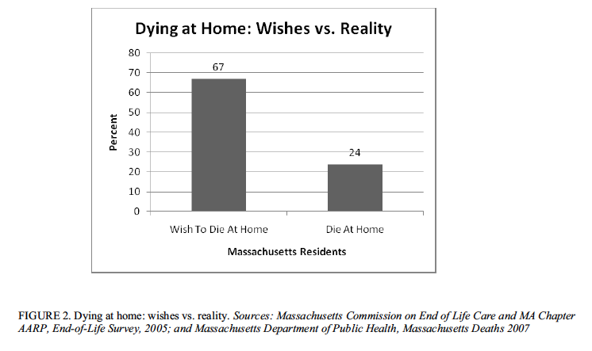

From: Patient-Centered Care and Human Mortality, Report and Recommendations of the Massachusetts Expert Panel on End-of-life Care, 2010.

When Does End-of-Life Care Begin?

Ideal High Quality End of Life Care

- Patient Understands Death May Be Approaching (Phase 3): Prognosis
- Patient Understands Quality of Life Tradeoffs

3. Patient Decisions match care delivered from Phase 3 to Death
  - Prefer Hospice ➔ Enrolled in Hospice for Optimal Beneficial Period
  - Prefer No Hospice ➔ Not Enrolled in Hospice

4. Services Delivered by Skilled Professionals to Optimize Quality of Life and Minimize:
  - Patient Physical Suffering
  - Patient Psychological or Existential Suffering
  - Family Suffering

Barriers to Ideal Care

- No Objective Measure for Onset of Phase 3
- Specialization Leading to Fragmented Care: Who is responsible/accountable for care from Phase 3 to Death?

Conceptual Framework Measuring Quality in EOL Care Continuum

Phase 3
- Patient understands prognosis
- Evaluation of Options
- Disease/Symptom Treatment

Phase 4
- Actively Dying
- Family experience

“Measuring What Matters”
Under Development by the American Academy of Hospice and Palliative Medicine and the Hospice and Palliative Nurses Association

- Hospice and Palliative Care – Comprehensive Assessment Within Certain Time Periods After Admission
- Any Pain Treatment
- Screening for Physical Symptoms
- Dyspnea Screening and Management
- Discussion of Emotional or Psychological Needs
- Discussion of Spiritual/Religious Concerns (NQF #1647)
- Proportion Admitted to Hospice for < 3 days (NQF #0216)
- Emergency Room Visit in Last 30 Days of Life (NQF #0211)
- Documentation of Surrogate
- Treatment Preferences (NQF #1641)
- Treatment Preferences Followed
- Family Evaluation of Palliative Care

http://aahpm.org/uploads/education/MWM%20Top%2012%20Measure%20Information%20and%20Comments.pdf, Accessed June 4, 2014.

Process of Development of “Measuring What Matters”

“Measuring What Matters” Assumes Access to Palliative Care

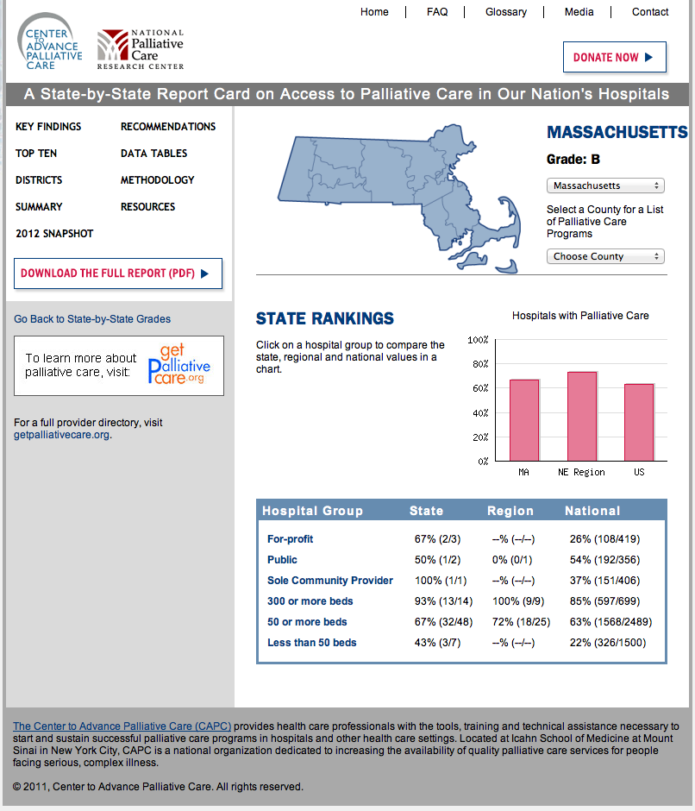

Concordance

Line | NQF# | Public Nomination | “Measuring What Matters”
1 | NQF #1632 | Consumer Assessments and Reports of EOL Care | Family Evaluation of Palliative Care
2 | NQF #326 | Advance Care Plan | Documentation of Surrogate
3 | NQF #216 | Proportion Admitted to Hospice < 3 days | Same
4 |  | Family Evaluation of Palliative Care | Same
5 | NQF #208 | Family Evaluation of Hospice Care | Family Evaluation of Palliative Care
6 | NQF #1639 | Dyspnea Screening | Dyspnea Screening & Management
7 | NQF #1638 | Dyspnea Treatment | Dyspnea Screening & Management
8 | NQF #1641 | Treatment Preferences (currently in SQMS) | Same; also Treatment Preferences Followed
9 | NQF #1647 | Beliefs/Values Addressed | Discussion of Spiritual/Religious Concerns
10 | NQF #1634 | Pain Screening | Screening for Physical Symptoms
11 | NQF #1637 | Pain Assessment | Hospice and Palliative Care Comprehensive Assessment
12 | NQF #1617 | Bowel Regimen for Patients Treated with an Opioid | ------
13 |  | ----- | Any Pain Treatment
14 |  | ----- | Discussion of Emotional or Psychological Needs
15 | NQF #0211 | ----- | Emergency Room Visit in Last 30 Days of Life

