Massachusetts All-Payer Claims Database:
Technical Assistance Group (TAG)
August 12, 2014

Agenda
- Compliance
- Housekeeping Items
- ACA Membership Reporting
- Profile Reports
- Substance Abuse Denial Study
- Questions

Compliance
THANK YOU!

Housekeeping Items
- Payer Associations
- V2 to V3 Profiles
- Risk Adjustment Update
- NAIC Codes (PR017)
- QHP fields (PR004, ME045, ME126)
- Student Health Plans

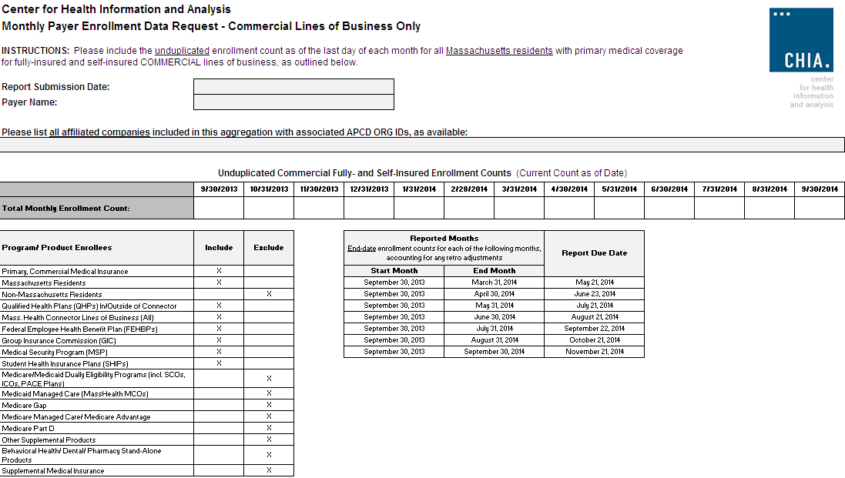

Profile Reports

New Profile Reports

- CHIA recently contracted with a vendor to produce profile reports of Release 2.1 data for the following submitters:
(Aetna (select ids), Celticare, CIGNA (select ids), Connecticare, BCBS of MA, BMC HealthNet, Fallon, Harvard Pilgrim Health Care, Health Plans Inc., MassHealth, Neighborhood Health Plan, Network Health, Tufts Health Plan, United (select ids), WellPoint, Inc.)
- CHIA intends to post the profiles to its website in September to help APCD users understand the richness of the dataset. The reports do not contain protected health information or cost information.

- The reports were produced for two file types:
Medical Claims and Member Eligibility.
- The reports are based on Release 2.1 data:
2012 incurred claims submitted as of September 2013,
2012 eligibility data submitted as of September 2013.
- The profiles have been assembled in EXCEL workbooks with multiple tabs.

New Profile Reports: Valid Values Summary

Variable | Data Element | Number of Records with Missing Values | % Records with Missing Values | Number of Records with Valid Values | % Records with Valid Values | Number of Records with Unrecognized Values | % Records with Unrecognized Values | Carrier Proposed Threshold | APCD Standard Threshold
AccidentIndicator | MC126 | 0 | 0% | 12,568,572 | 100% | 0 | 0% |  | 100%
AdmissionSource | MC021 | 8,323,016 | 66% | 4,244,944 | 34% | 612 | 0% |  | 80%
AdmissionType | MC020 | 8,334,753 | 66% | 4,233,787 | 34% | 32 | 0% |  | 98%
AdmittingDiagnosisCleaned | MC039 | 11,877,835 | 95% | 690,737 | 5% | 0 | 0% |  | 98%
AuthorizationNeeded | MC117 | 0 | 0% | 12,568,572 | 100% | 0 | 0% |  | 100%
CapitatedEncounterFlag | MC081 | 0 | 0% | 12,568,572 | 100% | 0 | 0% |  | 100%
ClaimLineType | MC138 | 0 | 0% | 12,568,572 | 100% | 0 | 0% |  | 90%
ClaimStatus | MC038 | 0 | 0% | 12,568,572 | 100% | 0 | 0% |  | 98%
DenialReason | MC124 | 11,489,238 | 91% | 1,077,227 | 9% | 2,107 | 0% |  | 80%
DeniedFlag | MC123 | 0 | 0% | 12,568,572 | 100% | 0 | 0% |  | 100%
DischargeDiagnosisCleaned | MC136 | 12,568,572 | 100% | 0 | 0% | 0 | 0% |  | 80%

New Profile Reports: Missing Summary

Variable | Data Element | Number of Records with Missing Values | Number of Records with Non-Missing Values | % Records with Missing Values | % Records with Non-Missing Values | Carrier Proposed Threshold | APCD Standard Threshold
PaymentArrangementTypeCleaned | MC113 | 0 | 30,631,112 | 0% | 100% |  | 90%
PlanRenderingProviderIdentifier_Linkage_ID | MC134 | 26 | 30,631,086 | 0% | 100% |  | 100%
PrincipalDiagnosisCleaned | MC041 | 216,430 | 30,414,682 | 1% | 99% |  | 99%
ProcedureCodeCleaned | MC055 | 2,213,420 | 28,417,692 | 7% | 93% |  | 92%
ProcedureCodeType | MC130 | 2,323,372 | 28,307,740 | 8% | 92% |  | 80%
ProcedureModifier1 | MC056 | 10,026,401 | 20,604,711 | 33% | 67% |  | 20%
ProcedureModifier2 | MC057 | 30,334,405 | 296,707 | 99% | 1% |  | 3%
ProcedureModifier3 | MC108 | 30,611,871 | 19,241 | 100% | 0% |  | 0%
ProcedureModifier4 | MC109 | 30,630,412 | 700 | 100% | 0% |  | 0%
ProductIDNumber_Linkage_ID | MC079 | 0 | 30,631,112 | 0% | 100% |  | 100%
ProviderLocation_Linkage_ID | MC135 | 26 | 30,631,086 | 0% | 100% |  | 98%
ReferralIndicator | MC118 | 0 | 30,631,112 | 0% | 100% |  | 100%

New Profile Reports

- The liaison for each carrier will send instructions via e-mail for accessing the reports on CHIA’s on-line system in the next week.
- If you have questions about the reports or comments you would like CHIA to consider including in the posted reports, please contact your APCD Liaison by September 15, 2014.

Substance Abuse Denial Study

Required by Chapter 258 of the Acts of 2014,
Section 35
“An Act to increase opportunities for long-term substance abuse recovery"

Report Specifications:
- Incurred in CY 2013 and adjudicated thru 6/30/14.
- Insured lines of business only.
- Carrier is primary insured.
- Based on final disposition of claim.
- Definition of Substance Abuse will be attached.

Substance Abuse Study Key Dates

- Today, August 12th – Announcement at TAG Webinar
- Monday, August 18th – Request Data via Liaisons

- Week of August 25th – Follow Up Conference Call
- Friday, September 12th – Submission Deadline

Upcoming Events

- August – APCD Membership comparison
- August/September – Profile Reports
- August/September – Connector Risk Assessment Simulation
- September/October – Substance Abuse Study

QUESTIONS?

Next Meetings

September 9, 2014 at 2:00pm

October 14, 2014 at 2:00pm

