CENTER FOR HEALTH INFORMATION AND ANALYSIS
Massachusetts All-Payer Claims Database: Technical Assistance Group (TAG)
September 9, 2014
Agenda
- Housekeeping Items
- Review of Common Issues
- Eligibility Guidance
- Risk Adjustment – Supplemental Diagnoses
- Data Intake/APCD Submission Guide Ver 4.0
- Questions

Housekeeping Items
- ACA Membership Reporting
- Substance Abuse Survey
- Profile Reports
- Pharmacy Versioning

Membership Reporting
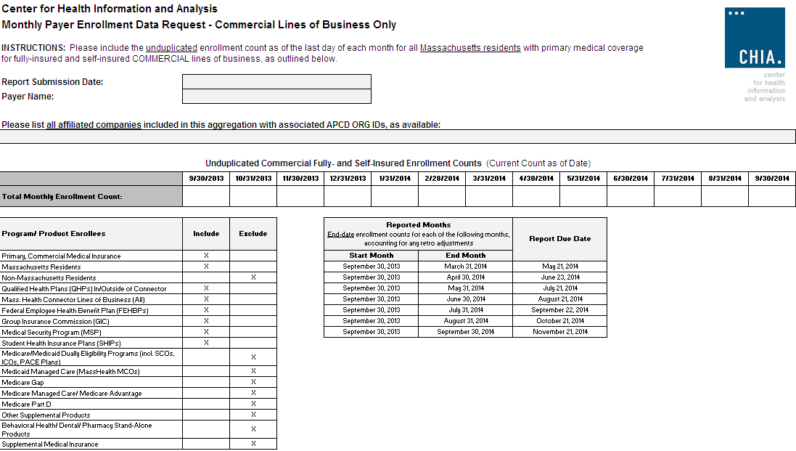

Substance Abuse Denial Study
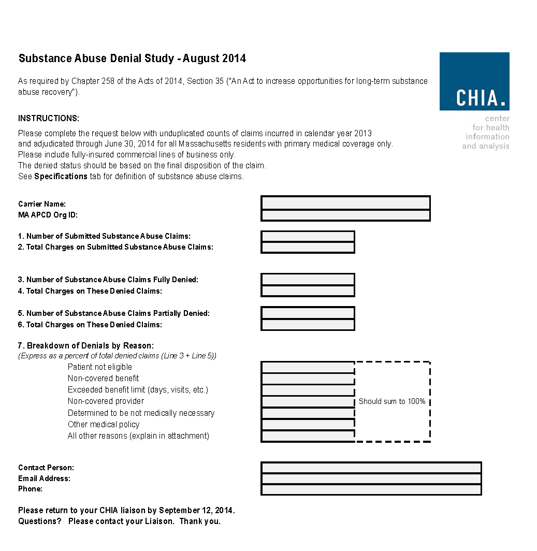

SUBSTANCE ABUSE SURVEY DUE BY FRIDAY SEPTEMBER 12.

Profile Reports
- Carriers: Aetna, Celticare, CIGNA, Connecticare, BCBS of MA, BMC HealthNet, Fallon, Harvard Pilgrim Health Care, Health Plans Inc., MassHealth, Neighborhood Health Plan, Tufts Health Plan, United, WellPoint
- The reports were produced for two file types:
Medical Claims and Member Eligibility.
- The reports are based on Release 2.1 data:
2012 incurred claims submitted as of September 2013,
2012 eligibility data submitted as of September 2013.
COMMENTS DUE BY MONDAY SEPTEMBER 15.

Review of Common Errors
- Fluctuations in number of lines submitted
- Review of error rates/edit patterns
- Data review

Line Number Fluctuations

Medical Claim Lines Per Month

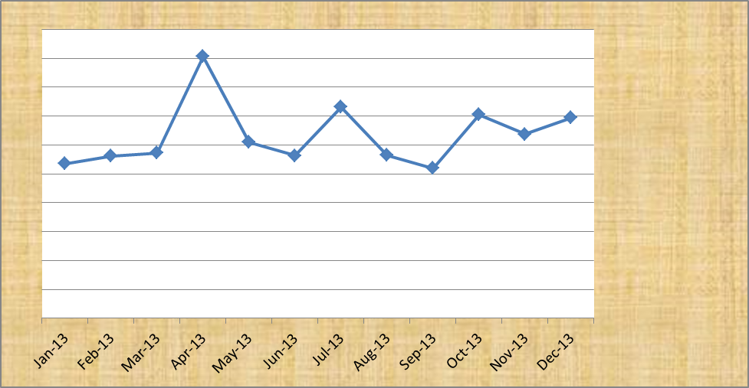

Line Number Fluctuations

Provider Lines Per Month

Review of Error Rates/Patterns
*WARNING - Actuarial Value indicates no cost sharing by the plan; AV reported as = 0.

Data Review

Risk Adjustment
Supplemental Diagnoses

Data Intake/APCD Submission Guide V4.0*

Data Element/Change | Agency Requesting
Make Member PCP ID (ME 046) an A2 category | CHIA
Require Attributed PCP Provider ID (ME124) from all medical carriers, not just TME carriers | CHIA
New Field - Cost Sharing Reduction | Connector
Update Look Up Table for Drug Unit of Measure (PC075) | Carriers
Update Look up Table for State Medicare Code (MC130) | Carriers
Make Purchased Thru MA Exchange (ME045) to an A category | Connector
Advice on how to code SCOs | DOI
Confirm member address fields are residential and not billing | DOI
New field – County for Medicare Advantage Premium | DOI
New field – Situs (where account is based) | DOI
Add additional “spans” for more attributes, notably address | DOI
New fields for MassHealth Enrollment Categories | Several
Make Select NPI fields an A category | CHIA (MDM)
New Field for consideration - Flag for inclusion/exclusion in HEDIS quality measures | Carriers
New flag for consideration – Paid Flag (Yes / No) | Carriers

*List is representative of suggested updates, not comprehensive

Version 4.0 Submission Guide
Tentative Timeframe
- September – Finalize business requirements
- October – Admin Bulletin
- November – Technical Advisory Group
- May – targeted implementation (6 months)
Upcoming Events

- September – rerun APCD Membership comparison
– publish Profile Reports
– Connector Risk Assessment Simulation
- September/October – Substance Abuse Study
- October – MA APCD Administrative Bulletin
- November – TAG on version 4.0 intake updates
- December – MA APCD Data Release

QUESTIONS?

Next Meetings
October 14, 2014 at 2:00pm
November 18, 2014 at 2:00pm*
*NOTE – off a week

